**Consensus Algorithm: A Brief Background**

A consensus algorithm is like Bitcoin’s PoW (Proof-of-Work), which requires miners to solve complex cryptographic mathematical puzzles for which they get rewarded with certain amount of Bitcoins. It is important to understand that each block which is added to the network must follow a set of consensus rules. E.g. Bitcoin’s consensus rules are no double spending, correct format of blocks, a certain amount of reward for miners etc. Blocks that fail to follow these consensus rules will be rejected. A blend of PoW consensus algorithms and the consensus rules offers a strong and reliable network which is secure and ensures that all the nodes in the network agree on a regular global state of the blockchain.

A consensus protocol has 3 basic features based on which its efficiency can be determined.

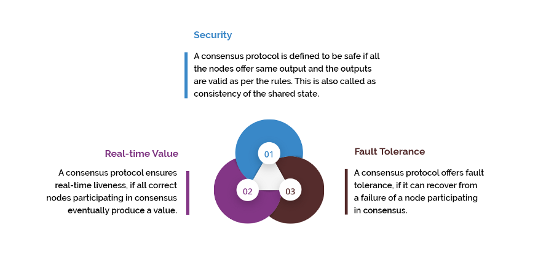

**Blockchain Consensus Algorithms Popular in the Market**

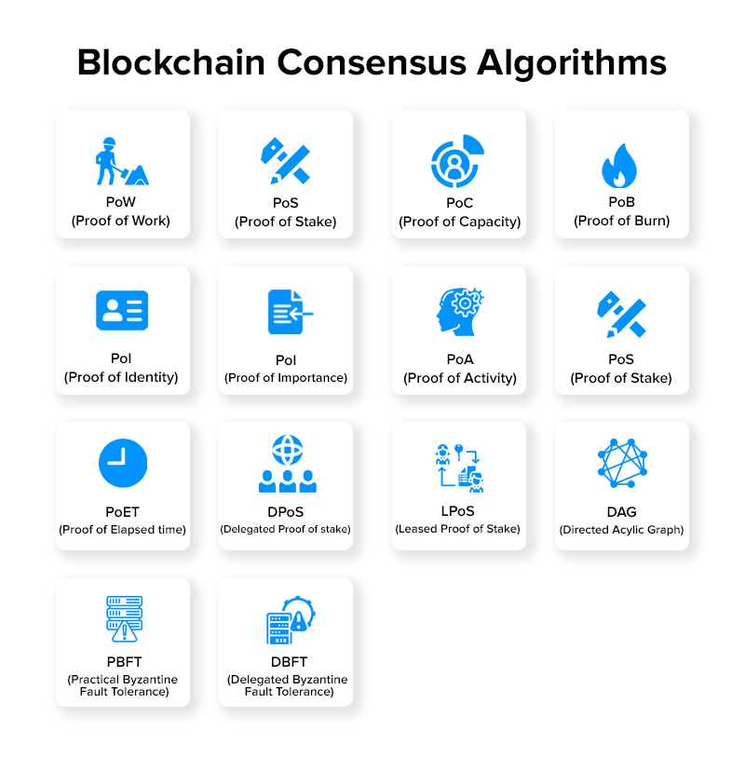

### 1. Proof of Work (PoW)

Developed by [Satoshi Nakamoto](https://uk.linkedin.com/in/satoshi-nakamoto-29b369ba), Proof of Work is the oldest consensus mechanism used in the Blockchain domain. It is also known as mining where the participating nodes are called miners.

In this mechanism, the miners have to solve complex mathematical puzzles using comprehensive computation power. They use different forms of mining methods, such as GPU mining, CPU mining, ASIC mining, and FPGA mining. And the one that solves the problem at the earliest gets a block as a reward.

In terms of its implementations, the Proof of Work (PoW) has not only influenced the financial industry, but also healthcare, governance, management and more. It has, in fact, offered the opportunity of multichannel payments and multi-signature transactions over an address for enhancing security.

### 2. Proof of Stake (PoS)

Proof of Stake is the most basic and environmentally-friendly alternative of PoW consensus protocol.

In this blockchain method, the block producers are not miners, but they act like validators. They get the opportunity to create a block over everyone which saves energy and reduces the time. However, for them to become a validator, they are supposed to invest some amount of money or stake.

Also, unlike that in the case of PoW, miners are provided with a privilege to take their transaction fees in this algorithm for there is no reward system in this consensus model.

This, as a whole, encouraged brands like Ethereum to upgrade their model from PoW to PoS in their [Ethereum 2.0 update](https://appinventiv.com/blog/introduction-to-ethereum-2-0/).

### 3. Direct Acyclic Graph (DAG)

Another basic yet prime blockchain consensus model that every [mobile app development services company](https://appinventiv.com/) working with Blockchain must be familiar with is DAG.

In this type of Blockchain consensus protocol, every node itself prepares to become the ‘miners’. Now, when miners are eradicated and transactions are validated by users itself, the associated fee reduces to zero. It becomes easier to validate transactions between any two closest nodes, which makes the whole process lightweight, faster, and secure.

### 4. Proof of Authority

Proof of Authority is a modified version of Proof of Stake in which the identities of validators in the network are at stake. In this, to verify the validator’s identity, the identity is the resemblance between validators’ personal identification and their official documentation. These validators put their reputation on the network. In Proof of Authority, the nodes (that become validators) are the only ones allowed to produce new blocks. Validators whose identity is at risk are incentivized to secure and preserve the blockchain network. In this proof, the number of validators are fairly small, around 25 or less.